**CREATE PARAMETERS – INSERT PARAMETERS**

**In a test case for different steps you may need to use different parameters**

**For example, when are testing a book flight ticket:**

**You will need to enter user name, password, credit card type, credit card number**

**So instead of entering these each time which is time consuming**

**You can create parameters and link them to different steps**

**Select the test case – Click on parameters – click on new parameter**

**Then enter the parameters**

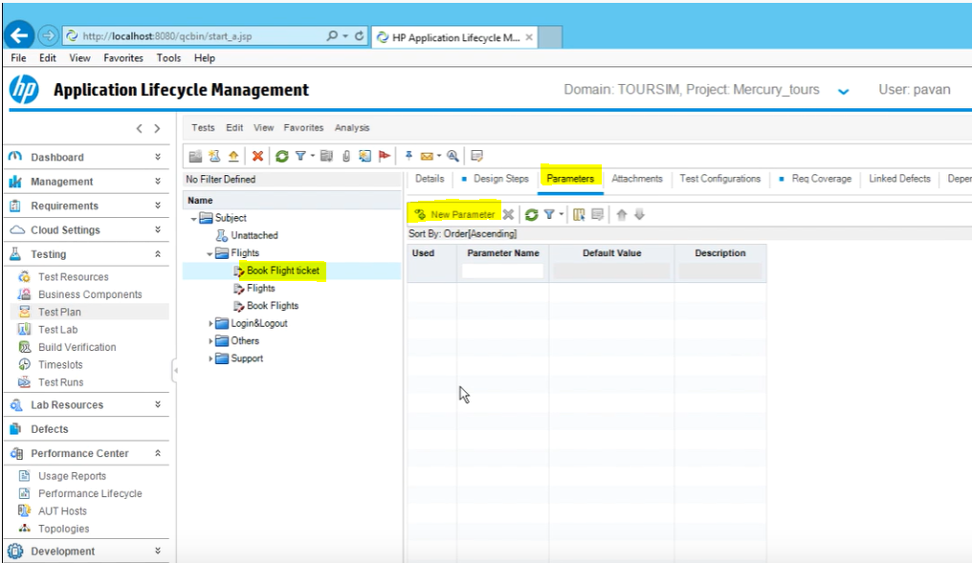

**Keep adding all the parameters you will need in the test**

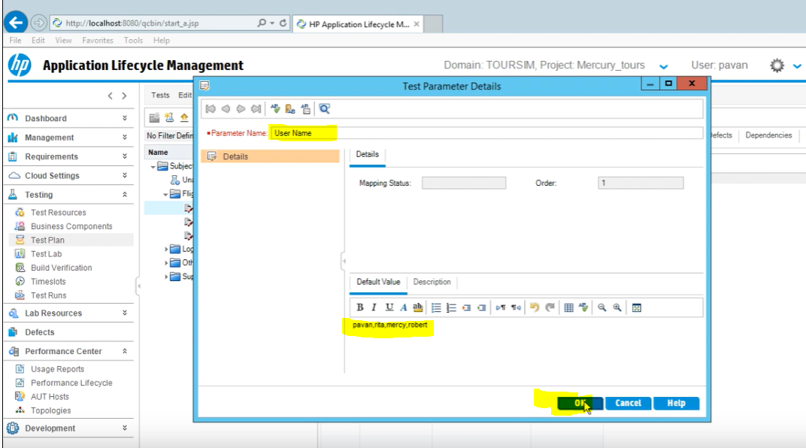

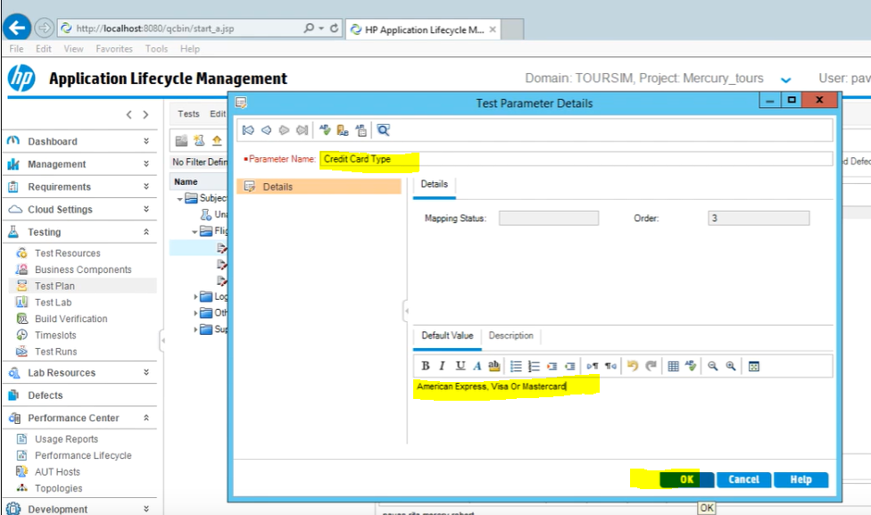

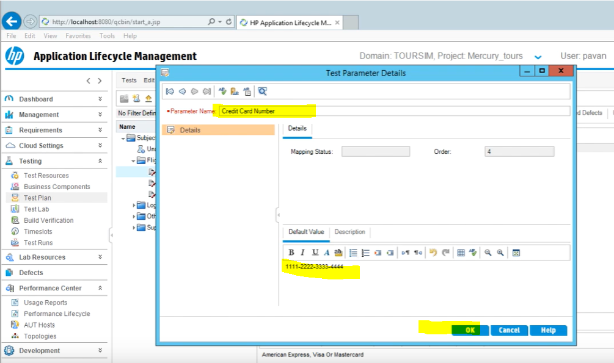

**Later, we will link them to the test steps.**

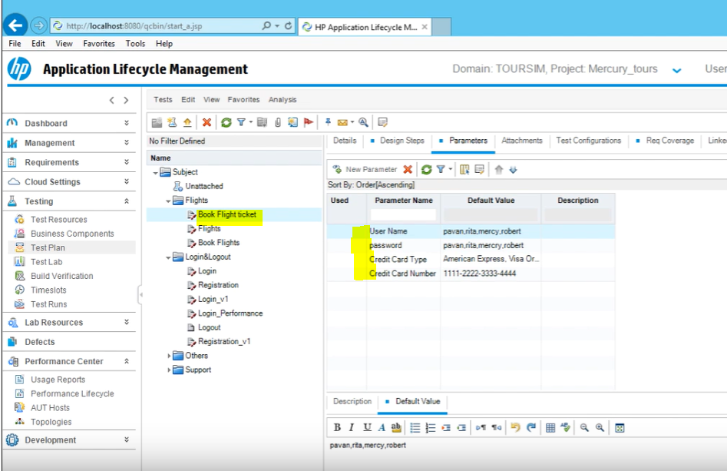

**Inserting Parameters**

**After parameters created, go back to the Design Steps Tab**

**Then click on the exact place where you want to insert the parameter**

**So in this example, you click on the first step and next to 2 where it says User Name to insert username parameters**

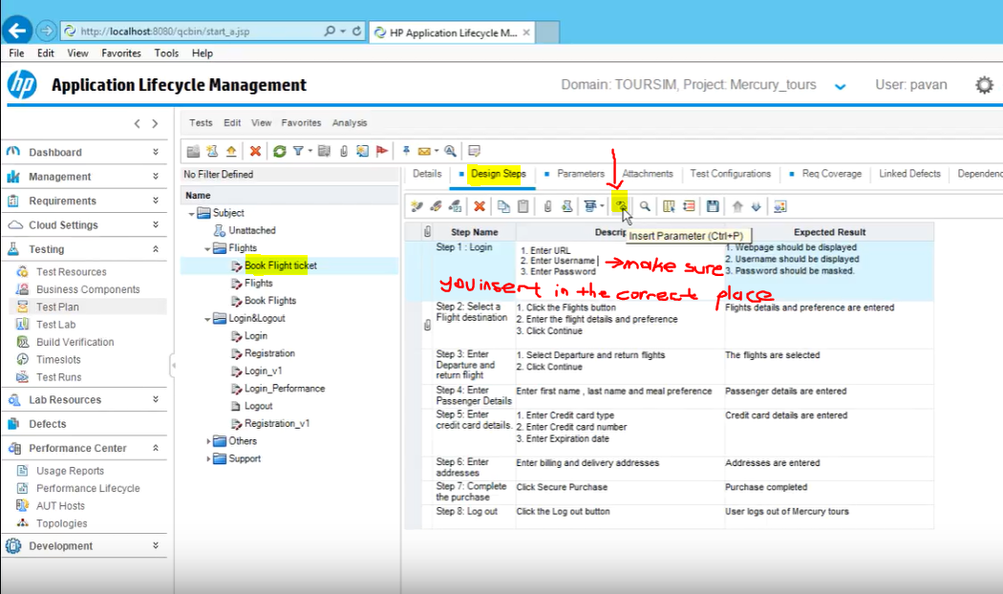

**Then select user name parameter and click ok**

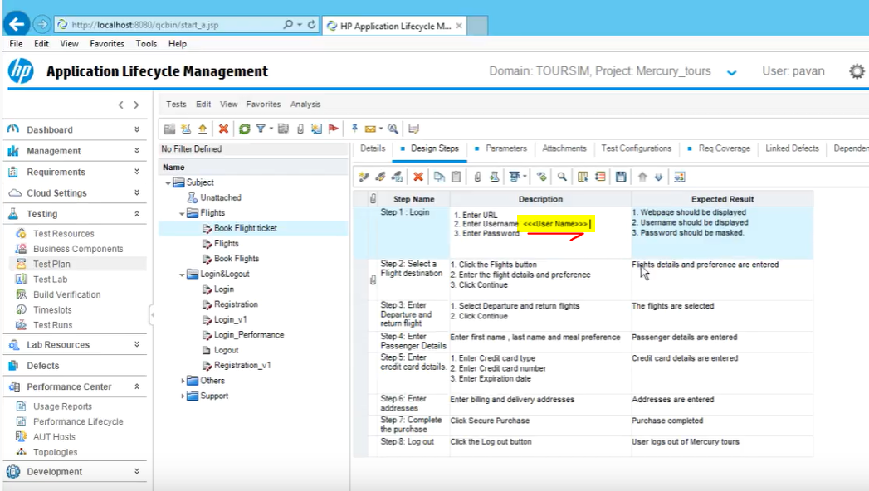

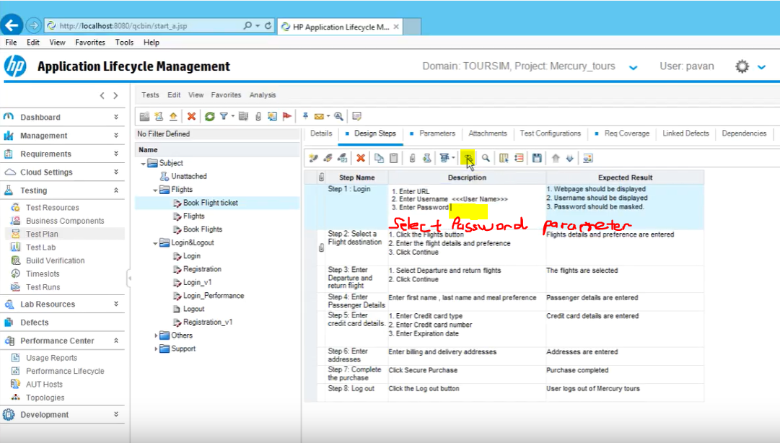

**If your parameters created while writing the test case you can also insert it From Design Step Details window, Click on insert parameter icon**



**You can use a parameter more than one time**

**You can also add parameters to expected results as well**

